Chasing a Civil War Ancestor resources:

Civil War Research for FEE

Ancestry http://www.ancestry.com/

Ancestry Civil War Collection

http://landing.ancestry.com/civilwar/default.aspx?o_iid=37978&o_lid=37978#

List of Civil War Records at Ancestry

http://www.ancestry.com/search/rectype/grouplist.aspx?group=war_civil

Search Results
 | 1 | American Civil War Soldiers
 | 1 | Civil War Pension Index: General Index to Pension Files, 1861-1934
 | 1 | U.S. Civil War Soldier Records and Profiles
 | 1 | U.S. Civil War Soldiers, 1861-1865

American Civil War Soldiers American Civil War Soldiers
Name: | Archibald Pierson
RESIDENCE: | Carlisle, Iowa
Enlistment Date: | 29 Aug 1862
Side Served: | Union
State Served: | Iowa
Service Record: | Enlisted as a Private on 29 August 1862 at the age of 37.  Enlisted in on 29 Aug 1862.  Promoted to Full Corporal on 16 Nov 1862.  Mustered Out on 28 May 1865 at Washington, DC.
Sources: | 71

Source Citation: Side served: Union; State served: Iowa; Enlistment date: 29 Aug 1862..
Source Information:
Historical Data Systems, comp.. American Civil War Soldiers [database on-line]. Provo, UT, USA: The Generations Network, Inc., 1999. Original data: Data compiled by Historical Data Systems of Kingston, MA form the .
Copyright 1997-2000
Historical Data Systems, Inc.
PO Box 35
Duxbury.
Description:
This database is a compilation of military records (including state rosters, pension records, and regimental histories) of individual soldiers who served in the United States Civil War.

U.S. Civil War Soldiers, 1861-1865 U.S. Civil War Soldiers, 1861-1865
Name: | Archibald Pierson
Side: | Union
Regiment State/Origin: | Iowa
Regiment Name: | 10 Iowa Inf.
Regiment Name Expanded: | 10th Regiment, Iowa Infantry
COMPANY: | B
Rank In: | Private
Rank In Expanded: | Private
Rank Out: | Private
Rank Out Expanded: | Private
Alternate Name: | Archibald/Pearson
Film Number: | M541 roll 21

Source Information:
National Park Service. U.S. Civil War Soldiers, 1861-1865 [database on-line]. Provo, UT, USA: The Generations Network, Inc., 2007. Original data: National Park Service, Civil War Soldiers and Sailors System, online <>, acquired 2007.
Description:
This database contains the names of approximately 6.3 million soldiers who served in the American Civil War. In addition to their names, information that may be listed for each soldier includes regiment, company, and rank.

Footnote http://www.footnote.com/

Footnote Civil War “Widows Pension” Applications:

From the very beginning of the Civil War, widows of men who served and died in the Union Army during the war were entitled to apply for pension benefits. After the war, further legislation was approved to allow for widows and dependents of men who served, survived the war, and died afterward.
Under the Dependent Pension Act, approved on June, 27, 1890, widows of soldiers serving in the Union Army could apply for a pension by proving the following:
- that the soldier served the Union for at least ninety days during the Civil War;
- that he was honorably discharged;
- that the widow provide proof of death, but it need not have been the result of his army service;
- that the widow is without other means of support than her day labor;
- that she married the soldier prior to June 27, 1890, the date of the act.
(2% complete as of 07/20/2010=757,260 documents)

Footnote Civil War Records

http://go.footnote.com/civilwar/

Original Documents » Civil War Service Records
Current Image Count 67,181,506 (07/20/2010)

Civil War Service Records

Confederate Records (17 titles)
Compiled service records of Confederate soldiers, labeled with each soldier’s name, rank, and unit, with links to revealing documents about…
Search - Browse
Top of Form

Bottom of Form

Union Records (13 titles)
Compiled service records of Union soldiers, labeled with each soldier’s name, rank, and unit, with links to revealing documents about each soldier.
Search - Browse

Footnote Pension Index

Publication Number: T289
Publication Title: Organization Index to Pension Files of Veterans Who Served Between 1861 and 1900.
Publisher: NARA
State: Iowa
Arm Of Service: Infantry
Regiment: 10
Company: B
Name: Pierson, Archibald
Rank: P.
Date: 01 Dec 1888
State/arm Of Service: Iowa Inf.
Company/regiment: B,10
Collection Title: Civil War Pensions

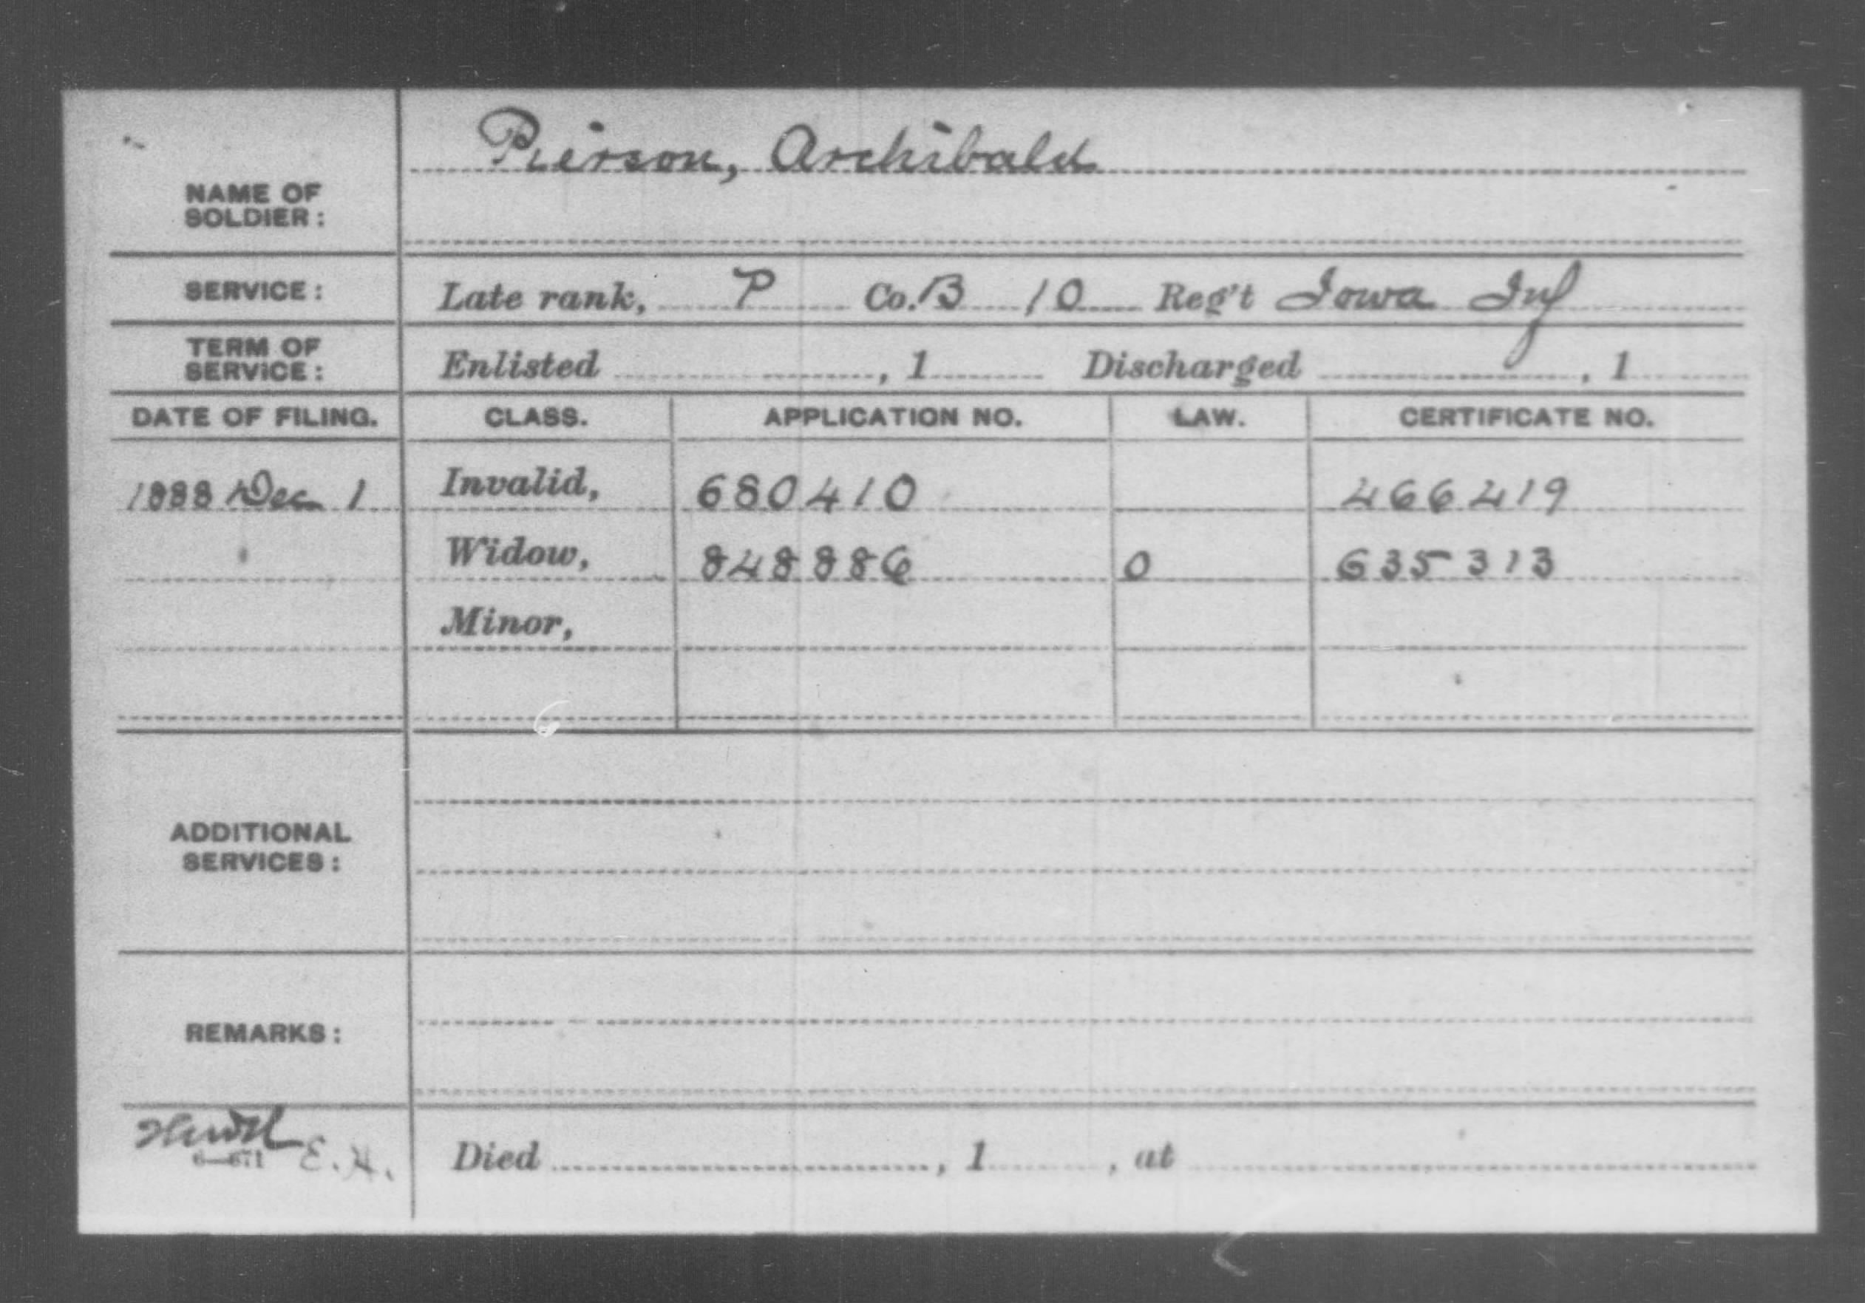

The National Archives http://www.archives.gov/

How to Order Older Military Service or Pension Records
Select the type of Military Service or Pension Records (pre-1917) you need and select the Order Online or Download the Form link:

Military Service Records
Order Online | Download the Form
Form Number: NATF 86
Use to: Order compiled records based on pre-1917 military service in the United States forces.

Military Pension/Bounty Land Warrant Applications
Order Online | Download the Form
Form Number: NATF 85
Use to: Order copies of military pension application files based on Federal (not State or Confederate) service between 1775 and 1903 (before World War I).
Categories of pension/bounty land files available using NATF Form 85:
- A complete Civil War and later pension application file (up to 100 pages), based on Federal (not State or Confederate) military service during the Civil War or later (includes the Pension Documents Packet.)
- A complete Federal pre-Civil War military pension application based on Federal military service before 1861 (includes the Pension Documents Packet.)
- A pension document packet that contains reproductions of eight documents containing genealogical information about the pension applicant, to the extent these documents are present in the file.
- A complete miltary bounty land application file based on service 1775-1855 (includes only rejected Revolutionary War applications).

Cost for Services

Compiled Military Service File (NATF 86)

Compiled records based on military service in the United States Army for regular forces raised by the Federal Government (officers who served before June 30, 1917 and enlisted men who served before October 31, 1912), Confederate Armed Forces (officers and enlisted men, 1861-1865), and volunteer service during wars from the Revolutionary War through the Phillipine Insurrection, (1775-1902).

Fee (includes shipping & handling): | $25.00
Federal Military Pension Application - Civil War and Later Complete File (NATF 85D)

Reproduction of the complete pension application file (up to 100 pages), based on Federal (not State or Confederate) military service during the Civil War or later. It includes the Pension Documents Packet and all other information of an official or personal nature in the file. If the file exceeds 100 pages, you will receive a form and instructions to order copies of the remaining pages.

Fee (includes shipping & handling): | $75.00
Federal Military Pension Application - Pre-Civil War Complete File (NATF 85A)

Reproduction of the complete pension application file, based on Federal (not State or Confederate) military service before the Civil War. It includes the Pension Documents Packet and all other information of an official or personal nature in the file.

Fee (includes shipping & handling): | $50.00
Federal Military Pension Applications - Pension Documents Packet (NATF 85B)

Reproduction of eight documents that contain genealogical information about the pension applicant, to the extent they are present in the file. These documents are for Federal (not State or Confederate) service between 1775 and 1912 ( before World War I). Select the FAQ at the right for a list of specific documents.

Fee (includes shipping & handling): | $25.00
Military Bounty-Land Warrant Application File (NATF 85C)

Bounty-land warrant application files are based on Federal (not State) military service before 1856. Documents in a bounty-land warrant application are similar to those in a pension application file. In addition, these files usually give the veteran's age and place of residence at the time the application was submitted.

Fee (includes shipping & handling): | $25.00

Articles in Prologue magazine

Civil War
Enhancing Your Family Tree with Civil War Maps (Summer 2003) - How to use an often-overlooked resource for filling out your Civil War research.
The Army Medal of Honor: The First Fifty-five Years (Summer 2001) - The Civil War origins of the Medal of Honor and guidance on how to find records of recipients.
Researching Confederate Marines in the Civil War (Winter 2001) - Tips for researching an often overlooked group of Civil War servicemen.
The Shady Side of the Family Tree: Civil War Union Court-Martial Case Files (Winter 1998) - Often, researching a family member's Civil War military service can be a double-edged sword.
Which Henry Cook? A Methodology for Searching Confederate Ancestors (Fall 1995) - How to use NARA records to pin down the identity of a Confederate soldier.
Civil War and Later Navy Personnel Records at the National Archives, 1861–1924 (Summer 1995) - United States Navy personnel records for the period 1861–1924 are one of the best secrets in genealogical research.
Civil War Draft Records: Exemptions and Enrollments (Winter 1994) - Looking for men who did not serve in the Civil War.
Confederate Medical Personnel (Spring 1994) - How to find your Civil War-era ancestor, if he or she served the Confederate army in a medical capacity, in the War Department Collection of Confederate Records.
Income Tax Records of the Civil War Years (Winter 1986) - Discover valuable information in records of the first U.S. income tax.

